1. Find YBUS of power system shown in figure below.

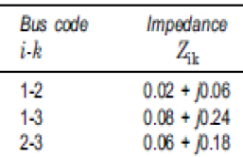 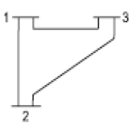

 

1. Find YBUS of power system.



(b)

Element Between Line Impedance Line charging

No. buses R X Susceptance

---------------------------------------------------------------------------------------------

1 1-5 0 0.2 --

2 1-6 0 0.2 --

3 2-5 0.1 0.2 0.004

4 2-3 0.2 0.1 --

5 3-4 0.05 0.2 0.005

6 4-6 0.02 0.2 --

1. Find YBUS of the power system network diagram.

